Standard Operating Procedures

--Brookfield DV-III Ultra

This S.O.P is a quick guide designed for viscosity measurement in Rm 1A26. All personnel should go through this S.O.P, the manual and training session scheduled with group assistant before s/he starts his/her research and tests. The content is intended to serve as one of the resources for its proper operation but not the only one. The following is focused on its application on determining the fluid behavior of Non- Newtonian fluids, and the storage and plotting for measured data using computer. For any other usage and specifications of this Rheometer, please refer to the Manual or speak to the technician or assistant.

# Units & Measurement Range

* Shear Stress: D/cm^2 (or N/m^2; 1 D/cm^2=0.1 N/cm^2);
* Shear Rate: 1/Sec (Sec^-1);
* Viscosity: cP (or mPa*s; 1 cP= 1 mPa*s, i. e. 1 Pa*s=1,000 cP).
* Viscosity: 6.2~122,800 (cP). (Cone and Plate, CP-41)
* For the accuracy of the results, the set speed for rheometer should result in measurements made between **10-100** on the instrument ***% torque scale***.

# Set-up

Please Refer to the Figure 1 in the Manual, Page 9;

# Quick Start

## For viscosity test:

* Make sure the Rheometer is leveled (by observing the bubble on top), if not, please level the Rheometer;
* Turn on the computer and open the “**RHEOCALC**” Program;
* Turn on the Rheometer, the “Power” Button is on the right hand side at the back of the base unit, then choose “1 – External Control” on the keypad to enable control from computer;

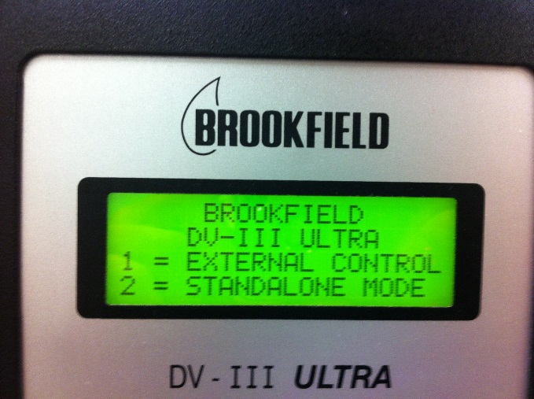

* On the computer, choose “COM 1” for communication, the interface of the application will close, reopen it;

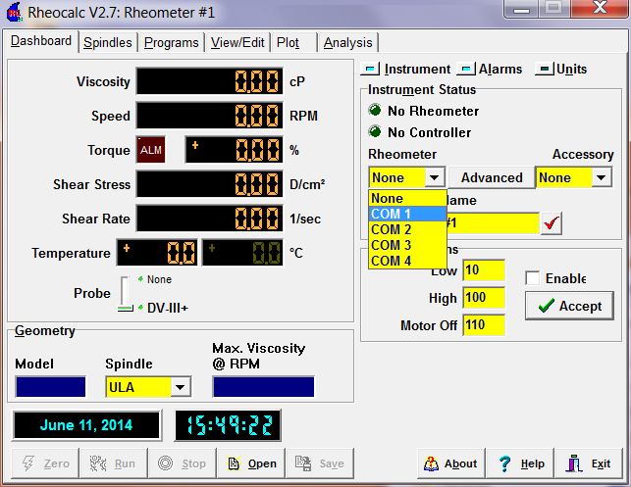

* Touch the sensor gently, if the reading of Torque changes, that means the communication between PC and DV-III is good;
* Autozero the rheometer with no cone or cup attached, using the “Autozero” Button, the torque displayed should be “± 0%” (Autozero on the rheometer please Refer to Page 15) with various readings when touched;

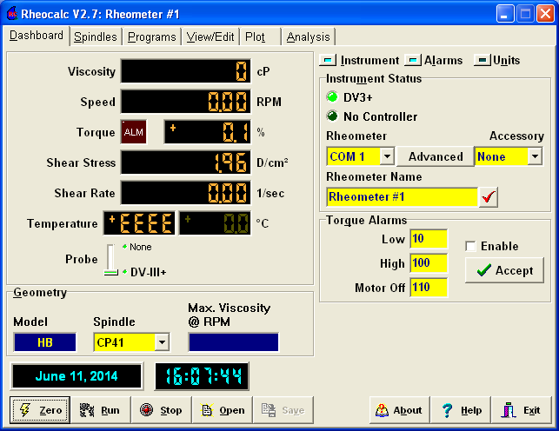

* Enter the spindle number from the drop box, in this case, CP-41;

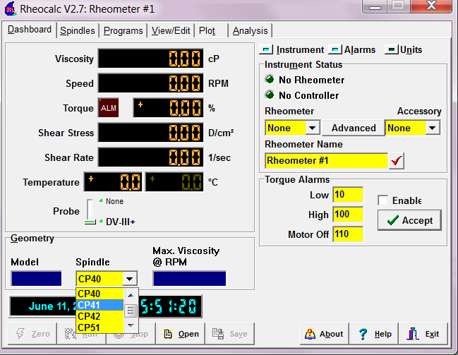

* Attach the spindle to the coupling nut (left-hand threads) with motor off, use the spindle wrench to secure the nut and thread the cone spindle by hand;
* Turn on the Toggle Switch, the *Pilot Light* is **Red**, which indicates that the Electronic Setting Function is sensing (enabled)*;

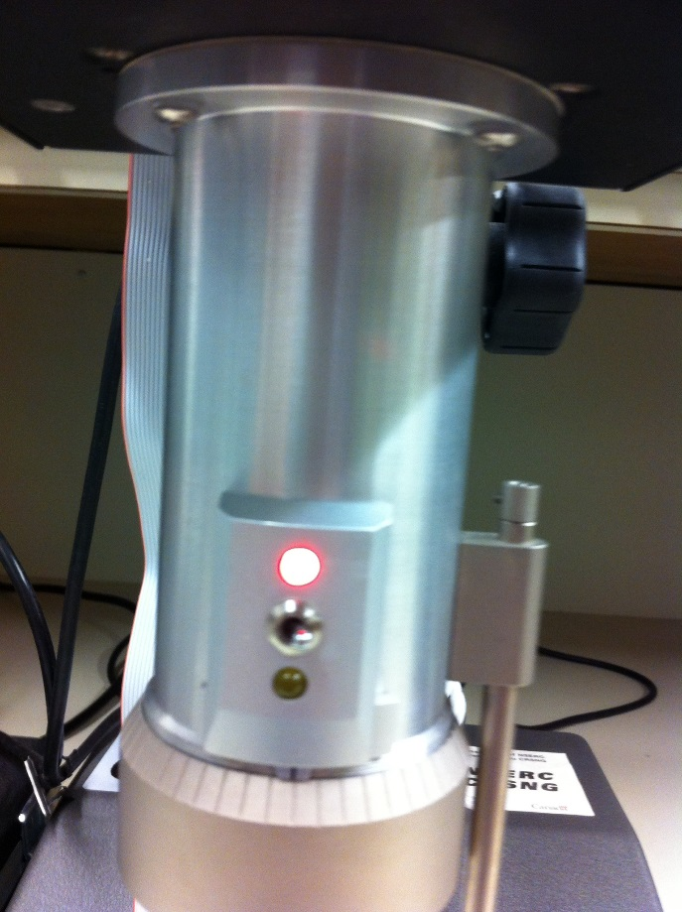

* Attach the cup, making sure not hit the cone/spindle with the cup;
* If the contact light (yellow) is illuminated, turn the adjustment ring clockwise/left, till the light is just breaking contact, i. e., flickering (Refer to Page 85, Fig A5);

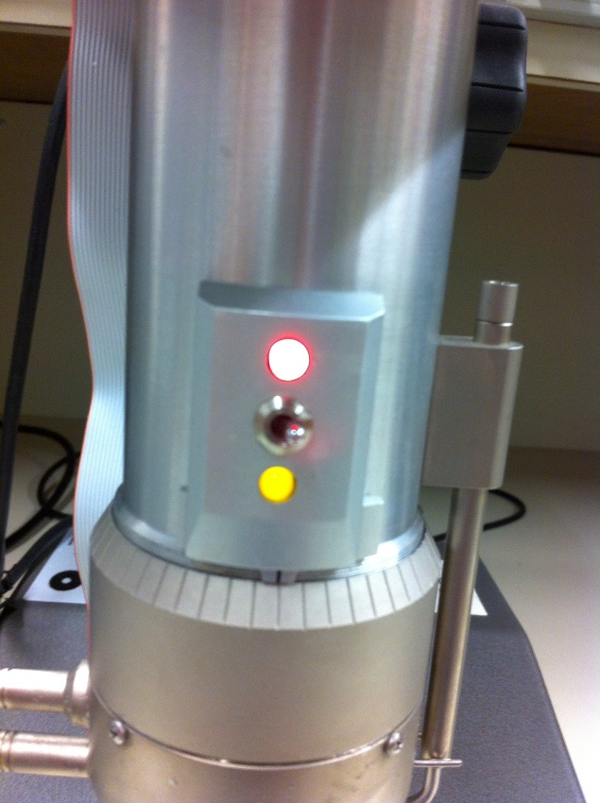

* If the contact light is not illuminated, slowly turn the adjustment ring counter-clockwise/right, till the light is on, then repeat the above step;
* Adjust the sliding reference marker to the closest full scale division mark (Refer to Page 85, Fig A6);
* Turn the adjustment ring one scale division to the left to meet the line on the sliding reference marker. The Yellow Contact Light should go **OFF** now, if so, turn the toggle switch off;
* Remove the sample cup carefully;
* Connect temperature sensor now if temperature is needed, the information for setting up the water bath is in the following appendix**;
* Put your sample in the middle of the sample cup, for CP-41, 2 mL is required for the sample, then install the cup carefully. Avoid bubble in this process;
  + Option 1: Click the **Run** at the bottom of the ***Dashboard*** Tab, then enter the desired shear rate/RPM for the cone, and record the measurements;

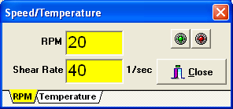

* + Option 2: Go over to the ***Program*** Tab, and load desired program, an example is given for measuring viscosity while the speed/shear rate is continuously increasing, for any other measures, please design your customized program by referring to the given example (Page ) and Page 39 in the Manual;

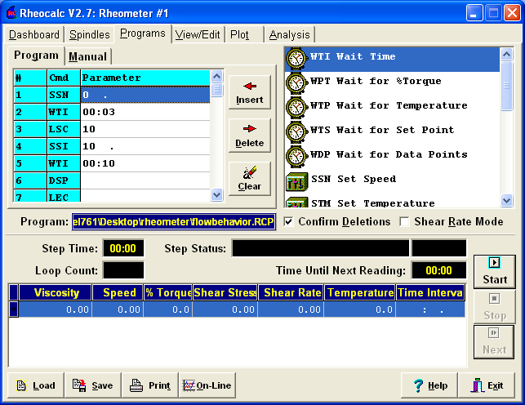

* When using the Program option, the data will be kept in designated file, you can view/edit the data in ***View/Edit*** Tab. The data can be exported into an .Excel file for record or further data analysis;
* Clean the spindle and cup, put the spindle back to proper container;
* For repetitive tests, please repeat the aforementioned steps. Due to the fluid behavior of most biomaterials, make sure to **zero** the rheometer **each time** even making measurements for the same fluid, in order to ensure the accuracy for each measurement.

# Plot & Analysis

The “**RHEOCALC**” Program allows to plot at most 5 different curves at the same time. You may choose the x- or y- axis as you wish. The figure given here contains the plots of PLLA (15%) [Pink], Alginate (3%) mixed with hydroxyapatite (0.75%) [Purple] and Alginate (2%) mixed with cells [Blue].

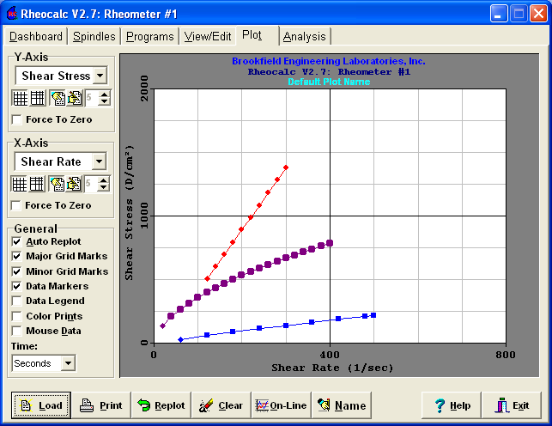

There are five models available for quick analysis built in the program. Depending on the fluid being tested and measured, choose the model that works the best for you in the ***Analysis*** Tab. Please refer to Page 59 for further information on each models. The given figure is using Herschel Bulkley model to fit the plot of mixture of 3% alginate and 0.75% hydroxyapatite. The confidence of fit is 100%.

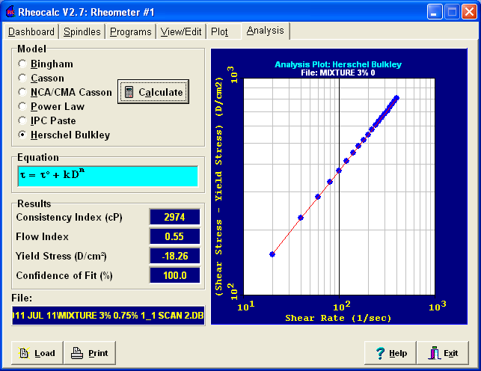

# Trouble Shooting

* Numeric keys, Program, Select, Spindle, and Options/Tab keys do not work.

--Please check if the rheometer is being “Locked Out”, if the screen on rheometer shows “LK”, then it is being locked out, press “3” key to unlock the rheometer. If the above mentioned methods do not work, please contact group assistant or the supplier for further help.

* No data displayed on the screen.

--Check that the rheometer is turn on;

--Check the data cable is connected to RS232 on the computer;

--Make sure that “COM1” is selected and the rheometer had been autozeroed;

--Check if the fluid’s viscosity is within the instrument’s measuring range;

# Illustrating Examples:

## For Viscosity Test:

|  |  |  |  |
| --- | --- | --- | --- |
| **#** | **Cmd** | **Parameter** | **Meaning** |
| **1** | **SSN** | 0.00 | *Set Speed, the initial speed is 0 RPM* |
| **2** | **WTI** | 00:03 | *Waiting Time, waiting 3 s for the RPM to reach desired value* |
| **3** | **LSC** | 10 | *Start Loop Counting, repeat the following step 10 times* |
| **4** | **SSI** | 10 | *Set Speed Increase, the speed increase 10 RPM* |
| **5** | **WTI** | 00:10 | *Waiting Time, waiting 10 s for the RPM to reach desired value* |
| **6** | **DSP** |  | *Display, display the results on the screen* |
| **7** | **LEC** |  | *End the Loop* |
| **8** | **FSO** | F:/****/ | *The path to store measured data* |

# Further Information

*With electrically conductive fluids, the function of Electronic Gap Setting should be turned off;

**Set up for Water Bath:

* + Fill the tank with water;
  + Connect the rubber tubes to the cup;
  + Connect the temperature sensor (the white line attached to the rheometer) to the back of the cup;
  + Turn the power on for the water bath, the Power switch is behind the water bath;
  + Press the Power button on the front to turn on the heater and pump (***WARNING:*** the pump will start working upon turned on, please make sure the tubes are well connected in case of leaking);
  + Set the temperature to desired value and wait it to heat up;
  + Once finish the test, turn off the pump and then disconnect everything;
  + Empty the tank.

For measurements of the fluid, whose viscosity range is out of DV-III, please contact Dale Claude in 1 D25, e-mail adress: [dale.claude@usask.ca](mailto:dale.claude@usask.ca).